Statistics Assignment Results

**Q1: College-wise Summary**

1. Calculate the: Mean, Median, Mode, Standard Deviation, Range for **Study_Hours** and **Exam_Score**

1. Create:
   * A histogram of Exam_Scores per college
   * A boxplot comparing Study_Hours between the two colleges

1. **Interpretation Task**:  
   Write a brief interpretation (4–5 lines):
   * Which college shows better average performance?
   * Which one has higher variability in study hours?

**Average Performance:** Based on the mean exam scores, the college with the higher average demonstrates better academic performance i.e., Alpha College has a higher mean Exam_Score of 69.64, and shows better average performance.

**Variability in Study Hours:** The standard deviation or the spread in the boxplot indicates variability. The college with the wider spread or larger standard deviation in Study_Hours i.e.; Alpha College with 2.55 has higher variability in Study_Hours.

**Q2: Two-Sample t-test**

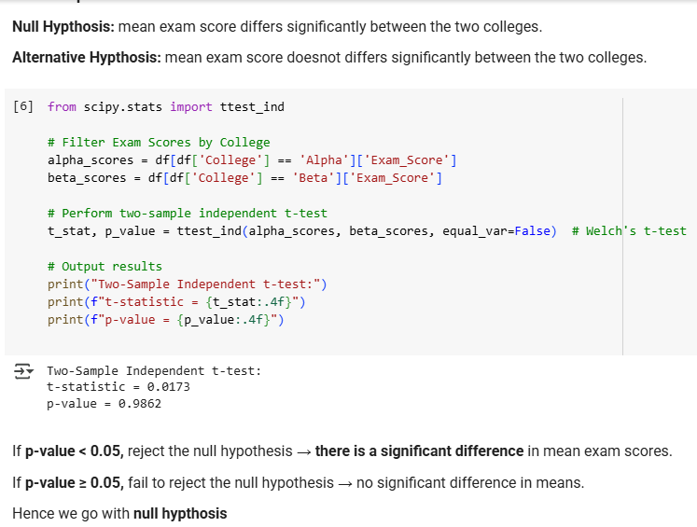

There is no significant difference.

**Q3: Chi-Square Test for Independence**

**Interpretation:**

* If p-value < 0.05: Reject H₀ → **There is a significant association** between College and Access to Resources.
* If p-value ≥ 0.05: Fail to reject H₀ → **No significant association** (they are likely independent).

**Q4: Simple Linear Regression**

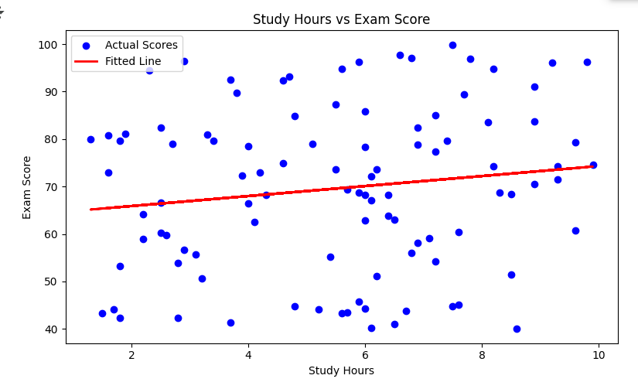

**Interpretation**

* **Slope**: Positive slope → As study hours increase, exam scores tend to increase.
* **Intercept**: Predicted score when study hours = 0.
* **R²**: Shows how much of the variation in Exam Score is explained by Study Hours.
  + Closer to 1 → strong relationship
  + Near 0 → weak relationship

**Q5: Multiple Regression (Advanced)**

**Interpretation:**

* **Which variable is more impactful?**
  + Compare coefficients and p-values. Larger, significant coefficients mean stronger impact.
* **Does access to resources help?**
  + If the p-value for Access_Resources_Binary < 0.05 and coefficient is positive → **Yes**, access significantly improves scores.